T-shirt | Size | Cost | Amount | Total
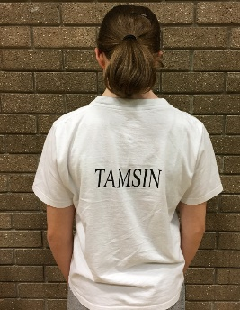 | Child Sizes | Child
 | 3/4 yrs 22/24” | £8.50
 | 5/6 yrs 26/28”
 | 7/8 yrs 30/32”
 | 9/11 yrs 33/34”
 | 12/13 yrs 35/36”
 | Adult Sizes | Adult
 | XS 36/38” | £10.50
 | S 40”
 | M 42”
 | L 44”
 | XL 48”
 | 2XL 50”
Club Hoodie | Size | Cost | Amount | Total
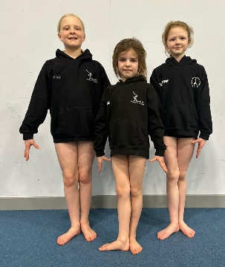  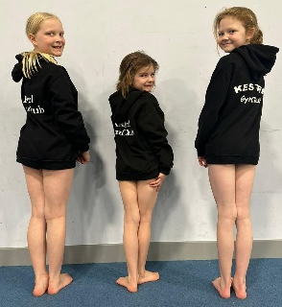 | Child Sizes | Child
 | 3/4 yrs 22/24” | £19.00
 | 5/6 yrs 26/28”
 | 7/8 yrs 30/32”
 | 9/11 yrs 33/34”
 | 12/13 yrs 35/36”
 | Adult Sizes | Adult
 | XS 36/38” | £25.00
 | S 40”
 | M 42”
 | L 44”
 | XL 48”
 | 2XL 50”
Club leotard long sleeve | Size (female) | cost | Amount | Total
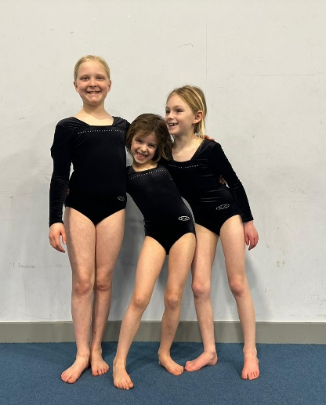 | Child Sizes | Child
 | 3/4 yrs 24” | £25.00
 | 5/6 yrs 26”
 | 7/8 yrs 28”
 | 9/10 yrs 30”
 | 11/12 yrs 32”
 | 13/14 yrs 34”
 | Adult Sizes | Adult
 | 15+ yrs 36 | £27.00
 | 15+ yrs 38
 | 15+ yrs 40”
Club leotard sleeveless | Size (female) | cost | Amount | Total
 | Child Sizes | Child
 | 3/4 yrs 24” | £22.00
 | 5/6 yrs 26”
 | 7/8 yrs 28”
 | 9/10 yrs 30”
 | 11/12 yrs 32”
 | 13/14 yrs 34”
 | Adult Sizes | Adult
 | 15+ yrs 36 | £24.00
 | 15+ yrs 38
 | 15+ yrs 40”
Club Leotard sleeveless | Size (Male) | cost | Amount | Total
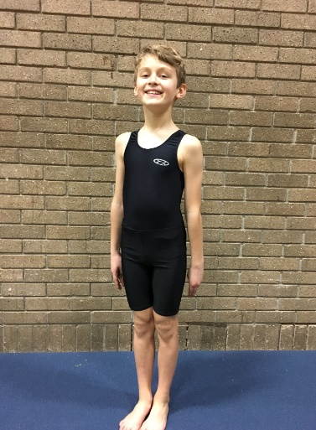 | Child Sizes | Child
 | 5/6 yrs 26” | £20.00
 | 7/8 yrs 28”
 | 9/10 yrs 30”
 | 11/12 yrs 32”
 | 13/14 yrs 34”
 | Adult Sizes | Adult
 | 14/15 yrs 36” | £23.00
 | 15+ yrs 38”
 | 15+ yrs 40”
Plain club shorts | Size (female) | cost | Amount | Total
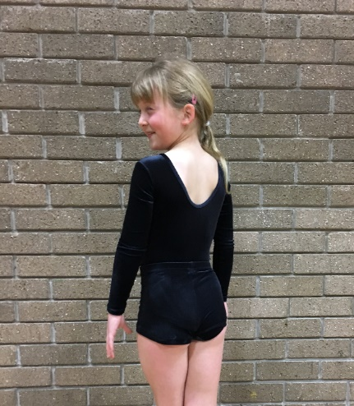 | Child Sizes | Child
 | 3/4 yrs 24” | £14.00
 | 5/6 yrs 26”
 | 7/8 yrs 28”
 | 9/10 yrs 30”
 | 11/12 yrs 32”
 | 13/14 yrs 34”
 | Adult Sizes | Adult
 | 15+ yrs 36 | £17.00
 | 15+ yrs 38
 | 15+ yrs 40”
Plain Club shorts | Size (male) | cost | amount | Total
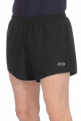 | Child Sizes | Child
 | 5/6 yrs 26” | £17.00
 | 7/8 yrs 28”
 | 9/10 yrs 30”
 | 11/12 yrs 32”
 | 13/14 yrs 34”
 | Adult Sizes | Adult
 | 14/15 yrs 36” | £30.00
 | 15+ yrs 38”
 | 15+ yrs 40”
Shorts with Name | Size (female) | cost | amount | Total
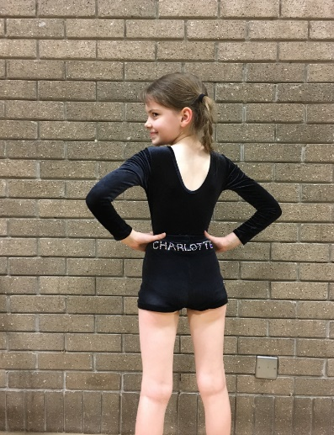 | Child sizes | Child
 | 6 - 5/6 yrs | £28.00
 | 8 - 7/8yrs
 | 10 - 9/10 yrs
 | 12 - 11/12 yrs
 | 14 - 13/14 yrs
 | Adult sizes | Adult
 | AXS - 14/15 yrs | £32.00
 | S -15/16 yrs
 | M - 16 + yrs
 | L - 16+ yrs

Clothing information
All clothing will be produced by ‘The Zone’, ‘A Star’ or ‘Team Kit Designs’.

Gymnasts’ clothing requirements
For Recreation groups and training:
Gymnasts are required to wear a leotard of their choice. Shorts are optional.

For displays:
All gymnasts are required to wear club leotard (and boys shorts).

For competitions:
All gymnasts in competition groups are required to have the following official Kestrel Club clothing in order to compete for the club:
• club tracksuit top
• Competition Leotard
• plain black shorts
- Plain black leggings

PAYMENT & OTHER ORDERING DETAILS - IMPORTANT
- There is no online ordering facility, so please email or download and print this order form, ensuring that you specify the size(s) you require.
- Pay the required amount online using your child’s name as a reference.
- Email Lyn Price at kestrelgymnastics@yahoo.co.uk with the date that the payment was made and for which item(s).
- Please email your completed form or hand to a coach, in an envelope with your child’s name on the front.
- In-stock items appear on the coach’s desk shortly after ordering.
- For items NOT in stock an order is placed with our suppliers. This can take up to 6 weeks. Once orders are in, an email is sent to you and kit can then be collected from coaches.

T-shirt, Hoodie and shorts have Gymnast’s name on them. Please confirm correct spelling below. Please note that names over 6 characters long may incur an extra charge.

Name to go on Clothing (capital letters please)……………………………………………………………………………………………

Questions
If you have any questions please email Lyn Price at kestrelgymnastics@yahoo.co.uk
If you are not sure about clothing sizes, please pop in at the end of a gymnastics session and the coaches can help you or your child to try on samples.
Please complete the details below and ensure you have ticked the right boxes for the clothing order.

Name of Gymnast:..................................................................................................................

Group (day/ time): ....................................................................................................................

Amount transferred/enclosed: ................................................................................................

Contact Number: ....................................................................................................................

